**Ideation Phase**

**Brainstorm & Idea Prioritization**

|  |  |
| --- | --- |
| Date | 28-06-205 |
| Team ID | LTVIP2025TMID49157 |
| Project name | Cosmetic Insights : Navigation cosmetics trends and consumer insights using Tableau |
| Maximum marks | 4 MARKS |

**Brainstorm & Idea Prioritization:**

During the brainstorming phase of the Cosmetic Insights project, I explored various ideas to help users make better decisions when choosing skincare products. I focused on key areas like skin type suitability, brand-wise price comparison, and product ranking. I also considered using visual tools like word clouds to display common ingredients and bar charts to show product distribution by category. The goal was to build an interactive and insightful dashboard using Tableau. These ideas were chosen to solve real user problems and provide meaningful cosmetic recommendations through data

**Step-1: Team Gathering, Collaboration and Select the Problem Statement**

In the first step, our team was formed by gathering individuals with diverse skills and shared interest in data analytics. We collaborated to understand each member's strengths, such as data visualization, research, and communication. After a group discussion and brainstorming session, we shortlisted several potential issues in the cosmetics industry

problem statement: **“Understanding consumer insights and trends related to sensitive skin products”**. This topic was chosen based on current market demand and its relevance to real-world cosmetic usage patterns.

**Team Leader :** Javvadi Venkata Karthik

**Team member :** Geddada Uday Kiran

**Team member :** Gonaboina Bhanu Akash

**Team member :** Gayathri

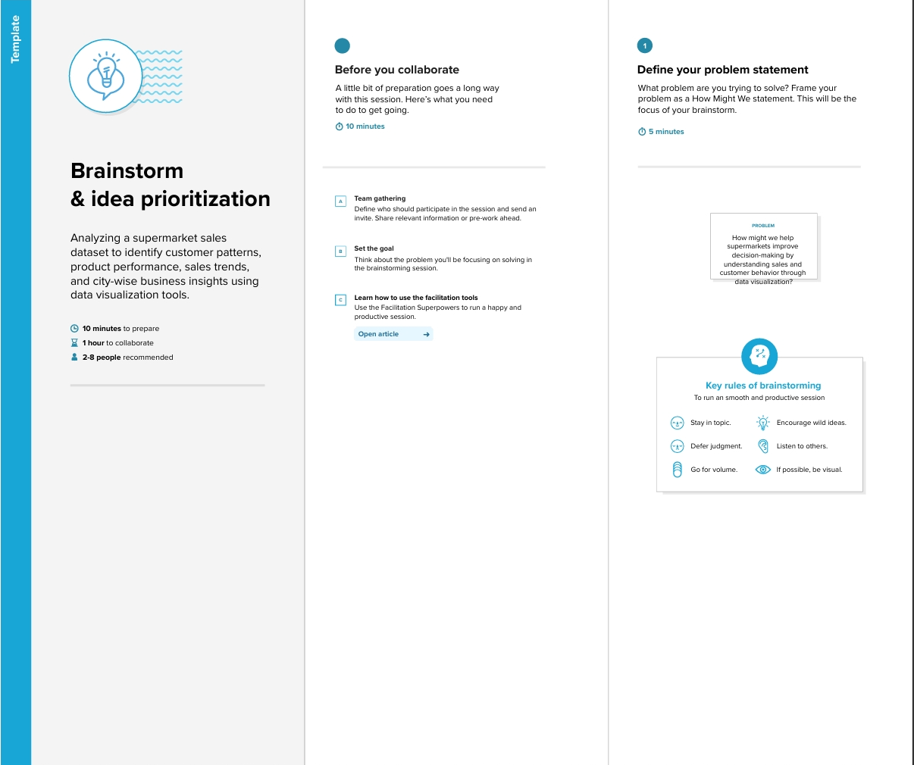

**Step-2: Brainstorm, Idea Listing and Grouping**

In this step, we listed multiple ideas related to analyzing cosmetics data, such as price comparison, skin suitability, and product ranking. These ideas were then grouped into categories like user needs, product features, and brand performance. This helped us focus on the most valuable insights for building the dashboard.

Then, we grouped similar ideas to identify key features for the dashboard like skin type filters, price analysis, and top brand insights.

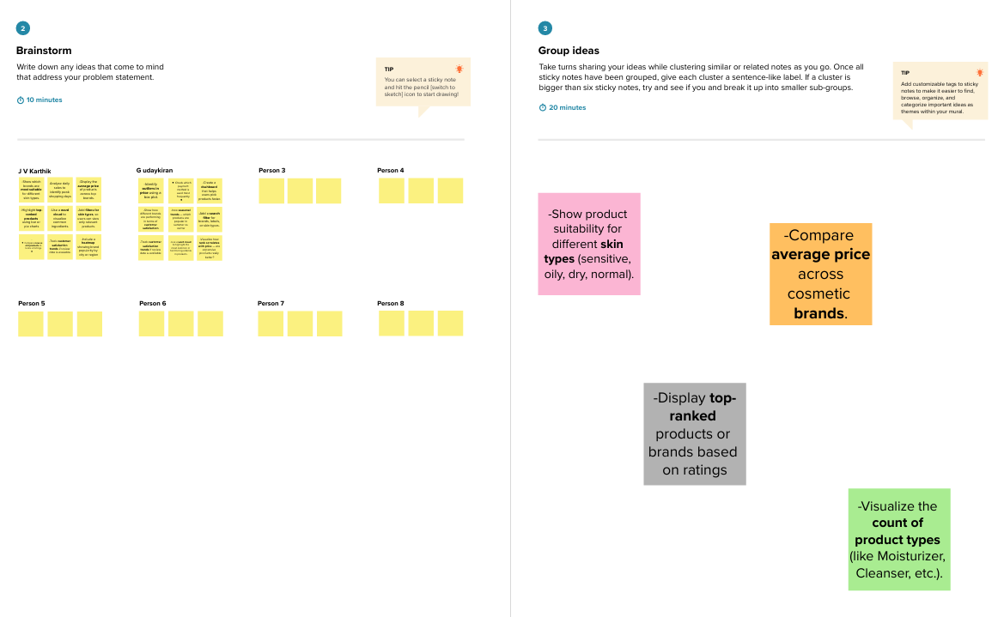

**Step-3: Idea Prioritization**

We prioritized ideas based on user needs, data availability, and project goals. Features like skin type suitability, price comparison, and top product ranking were selected as the most impactful for the dashboard.

**Identify Ingredients**

* List ingredients suitable and not suitable for sensitive skin (like aloe vera = suitable, parabens = not suitable).

**Consumer Preferences**

* Track what consumers with sensitive skin prefer (organic, fragrance-free, cruelty-free products).

**Product Reactions**

* Analyze common issues faced by sensitive skin users (itchiness, redness, dryness after use).

**Brand Comparison**

* Compare top brands offering sensitive skin-friendly products (e.g., Cetaphil vs. Nivea).

**Age & Gender Insight**

* Understand which age groups or gender are more concerned about sensitive skin products.

